# Cvičenie 10- Hrašna, Kurnas

**GRE tunel, QoS pre-classify**

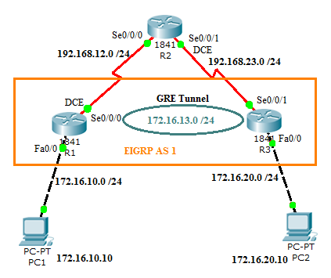

V D-ITG sme generovali 3 toky:

* Voice – 80,1kb/s, intenzita 50p/s, veľkosť paketu 200B
* Gaming – 13,6kb/s, intenzita 24p/s
* Data – veľkosť paketu 700B
  + Pri celkovej záťaži 79% – 8,4kb/s, 2p/s
  + Pri celkovej záťaži 123%– 63,4kb/s, 15p/s

79% zaťaženie:

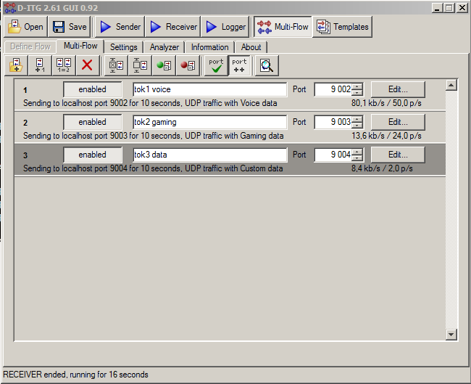

123% zaťaženie:

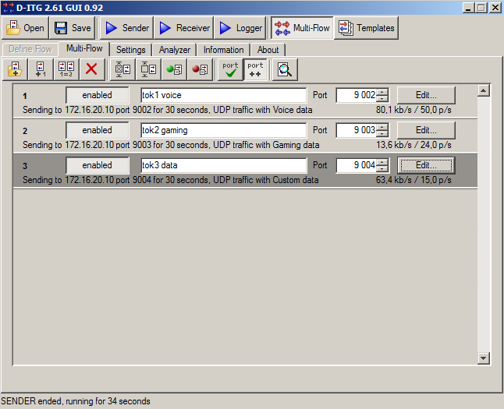

**Konfigurácia:**

R1 – konfigurácia WFQ:

policy-map WFQ

class class-default

fair-queue

interface Serial0/0/0

bandwidth 128

ip address 192.168.12.1 255.255.255.0

clock rate 128000

service-policy output WFQ

Značkovanie:

class-map match-all Tok1

match access-group 101

class-map match-all Tok2

match access-group 102

class-map match-all Tok3

match access-group 103

access-list 101 permit udp any any eq 9002

access-list 102 permit udp any any eq 9003

access-list 103 permit udp any any eq 9004

policy-map znacka

class Tok1

set dscp ef

class Tok2

set dscp af11

class Tok3

set dscp default

int fa0/0

service-policy output znacka

Nakonfigurovanie statického smerovania:

R1:

ip route 0.0.0.0 0.0.0.0 192.168.12.2

R3:

ip route 0.0.0.0 0.0.0.0 192.168.23.2

**GRE Tunnel:**

R1:

interface Tunnel1

ip address 172.16.13.1 255.255.255.0

qos pre-classify

tunnel source Serial0/0/0

tunnel destination 192.168.23.3

R2:

interface Tunnel1

ip address 172.16.13.3 255.255.255.0

tunnel source FastEthernet0/1

tunnel destination 192.168.12.1

Nakonfigurovanie statického smerovania cez vytvorený tunel:

R1:

ip route 172.16.0.0 255.255.0.0 172.16.13.3

R3:

ip route 172.16.0.0 255.255.0.0 172.16.13.1

1. Scenár **bez QoS** **preclassify, bez značkovania**

* 79% záťaž

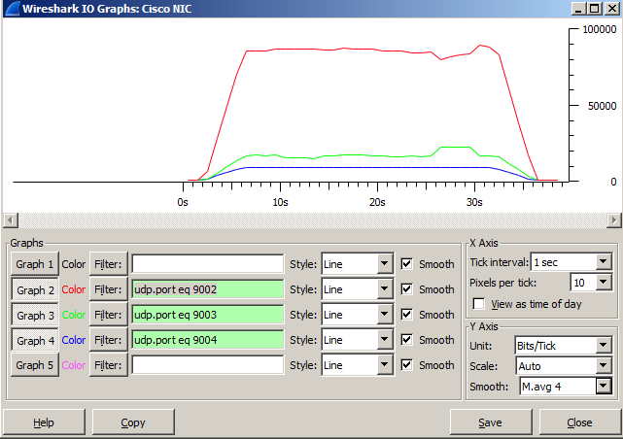

**************** TOTAL RESULTS ******************

__________________________________________________________

Number of flows = 3

Total time = 30.114000 s

Total packets = 2297

Minimum delay = -117.095000 s

Maximum delay = -116.764000 s

Average delay = -116.989956 s

Average jitter = 0.005863 s

Delay standard deviation = 0.056983 s

Bytes received = 319596

Average bitrate = 84.902969 Kbit/s

Average packet rate = 76.276815 pkt/s

Packets dropped = 350 (13.22 %)

Average loss-burst size = 70.000000 pkt

Error lines = 0

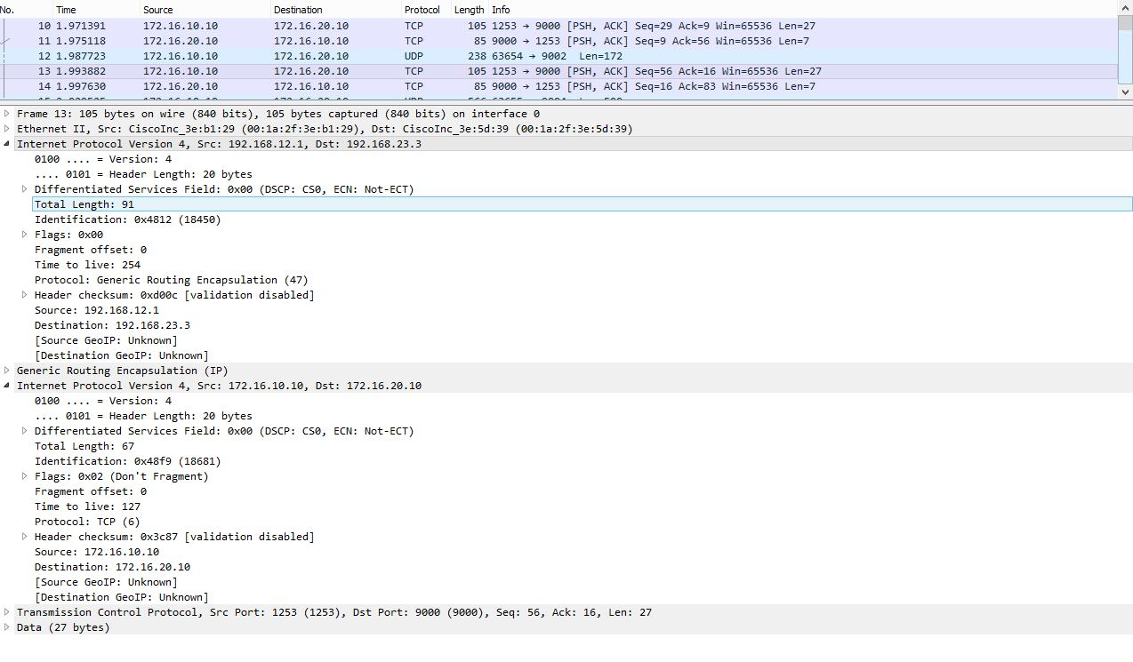

* B) 123% záťaž

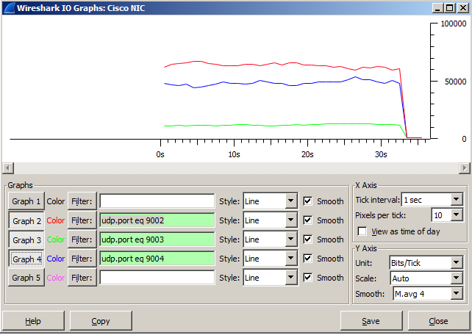

**************** TOTAL RESULTS ******************

__________________________________________________________

Number of flows = 3

Total time = 30.887000 s

Total packets = 2011

Minimum delay = -118.125000 s

Maximum delay = -117.139000 s

Average delay = -117.427769 s

Average jitter = 0.016243 s

Delay standard deviation = 0.206592 s

Bytes received = 390309

Average bitrate = 101.093405 Kbit/s

Average packet rate = 65.108298 pkt/s

Packets dropped = 669 (24.96 %)

Average loss-burst size = 1.264650 pkt

Error lines = 0

1. Scenár **bez QoS** **preclassify, so značkovaním**

* 79% záťaž

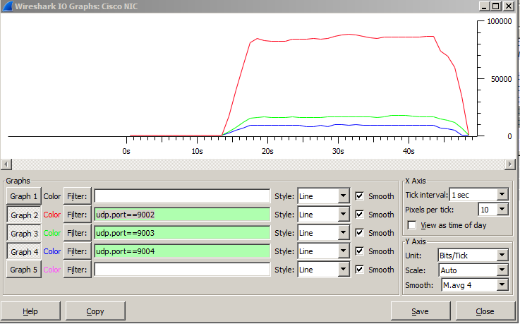

__________________________________________________________

**************** TOTAL RESULTS ******************

__________________________________________________________

Number of flows = 3

Total time = 30.167000 s

Total packets = 2274

Minimum delay = -126.337000 s

Maximum delay = -125.948000 s

Average delay = -126.105516 s

Average jitter = 0.006008 s

Delay standard deviation = 0.086563 s

Bytes received = 319217

Average bitrate = 84.653297 Kbit/s

Average packet rate = 75.380383 pkt/s

Packets dropped = 0 (0.00 %)

Average loss-burst size = 0 pkt

Error lines = 0

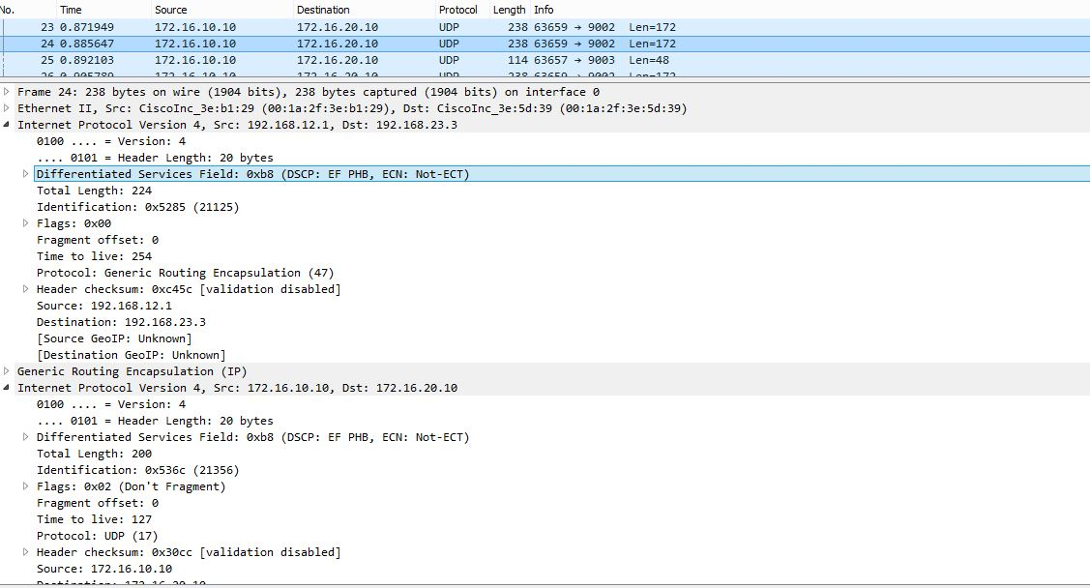

* B) 123% záťaž

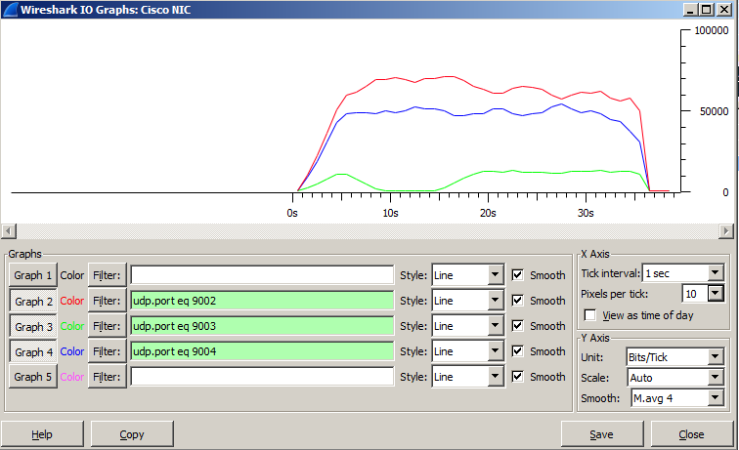

__________________________________________________________

**************** TOTAL RESULTS ******************

__________________________________________________________

Number of flows = 3

Total time = 30.887000 s

Total packets = 2011

Minimum delay = -118.125000 s

Maximum delay = -117.139000 s

Average delay = -117.427769 s

Average jitter = 0.016243 s

Delay standard deviation = 0.206592 s

Bytes received = 390309

Average bitrate = 101.093405 Kbit/s

Average packet rate = 65.108298 pkt/s

Packets dropped = 669 (24.96 %)

Average loss-burst size = 1.264650 pkt

Error lines = 0

1. Scenár **s QoS** **preclassify**

* 79% záťaž

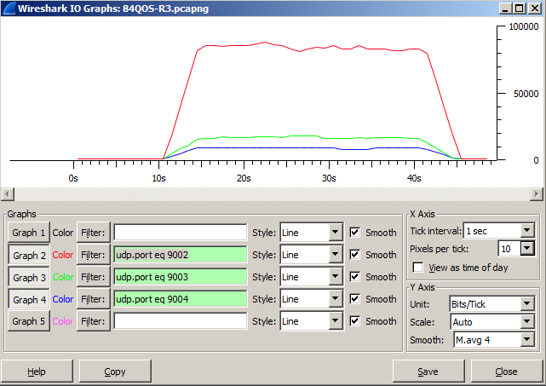

__________________________________________________________

**************** TOTAL RESULTS ******************

__________________________________________________________

Number of flows = 3

Total time = 30.706000 s

Total packets = 2273

Minimum delay = -116.725000 s

Maximum delay = -115.994000 s

Average delay = -116.479336 s

Average jitter = 0.005987 s

Delay standard deviation = 0.208947 s

Bytes received = 319037

Average bitrate = 83.120432 Kbit/s

Average packet rate = 74.024621 pkt/s

Packets dropped = 0 (0.00 %)

Average loss-burst size = 0 pkt

Error lines = 0

* B) 123% záťaž

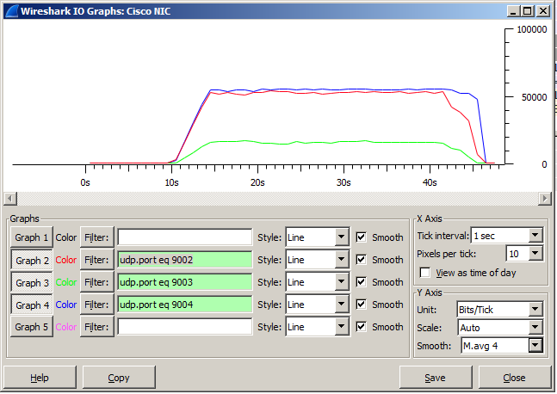

**************** TOTAL RESULTS ******************

__________________________________________________________

Number of flows = 3

Total time = 31.626000 s

Total packets = 2059

Minimum delay = -117.053000 s

Maximum delay = -114.875000 s

Average delay = -116.132366 s

Average jitter = 0.045334 s

Delay standard deviation = 0.487855 s

Bytes received = 395517

Average bitrate = 100.048568 Kbit/s

Average packet rate = 65.104661 pkt/s

Packets dropped = 576 (21.86 %)

Average loss-burst size = 2.691589 pkt

Error lines = 0

----------------------------------------------------------